Raspberry Pi Smesh Setup

Install Raspberry Pi OS on SD card

Remotely Connect to Raspberry Pi via SSH

Install Software and Dependencies on Raspberry Pi Troubleshooting Tips

# Install Raspberry Pi OS on SD card

 Go to: <https://www.raspberrypi.com/software/>  Download and install

Raspberry Pi Imager

 Insert SD card into your computer/laptop  Open

Raspberry Pi Imager

 Click on the **CHOOSE OS** box, then select:

Raspberry Pi OS (Legacy, 32-bit) Lite

Raspberry Pi OS (other)

Scroll down and select:

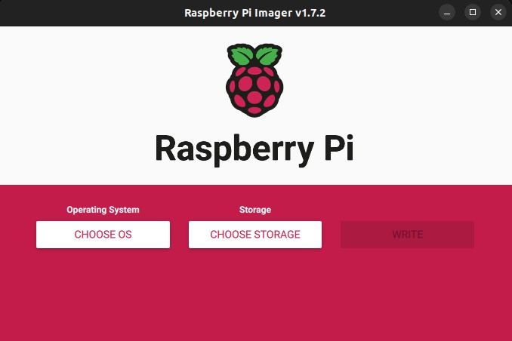

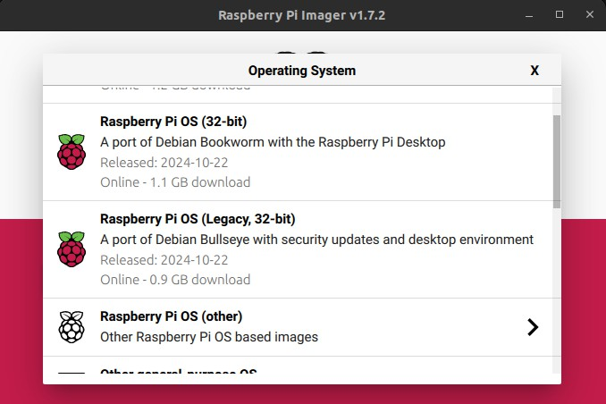

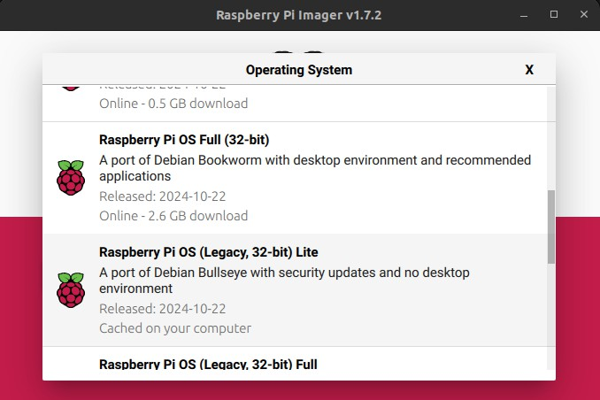

Click on the **CHOOSE STORAGE** box and select your SD card

Click on the Settings icon in the bottom right, then follow then steps:

Set hostname to system)

Tick the

Enable SSH

smeshX

box:

(where X represents the number of the current

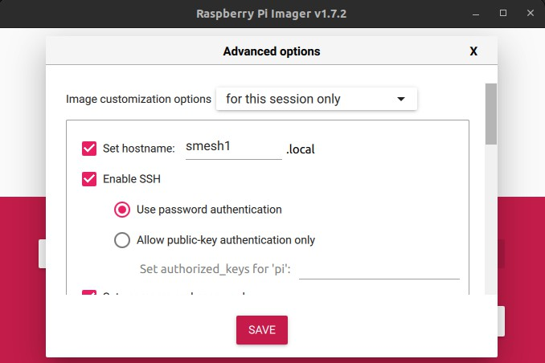

Set username and password to:

 Username:



pi

 Password:

smesh

Configure wireless LAN:

 SSID: name of your WiFi network

 Password: password of your WiFi network  Wireless LAN country:



US

Click **SAVE**

Click **WRITE**

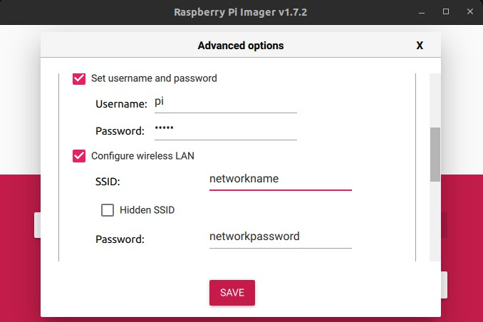

Once the Raspberry Pi OS has been installed, remove the SD card from your computer/laptop and put it in the Raspberry Pi.

Power the Raspberry Pi by plugging a micro USB cable to the PWR IN (connected to a battery pack or wall outlet).

A green LED should light up near the PWR IN slot to indicate that the Raspberry Pi is ON.

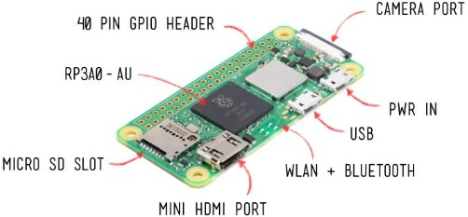

# Remotely Connect to Raspberry Pi via SSH

 After a couple minutes, the Raspberry Pi should have connected to your local WiFi network.

 Make sure your computer/laptop is connected to the same network.

Open a Terminal and enter the command: represents the number of the current system)

ssh [pi@smeshX.local](mailto:pi@smeshX.local)

(where X

During first SSH connection, you may get the following error:

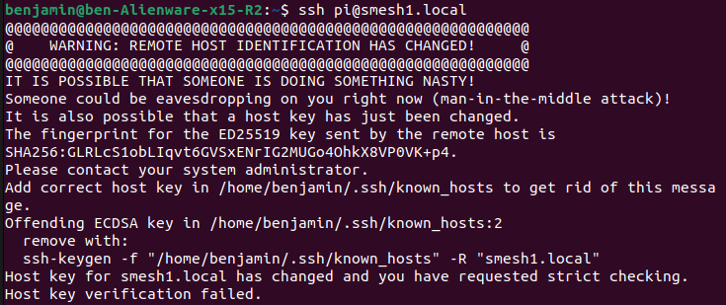

In such case:

 Go to your user folder on your computer/laptop  Find a folder named

.ssh

 Find a file named:

known_hosts

 Delete its content ansd save

 Try the connect again by entering the command: X represents the number of the current system)

ssh [pi@smeshX.local](mailto:pi@smeshX.local)

When asked: *Are you sure you want to continue connecting*, enter: Enter the password:

smesh

pi@smeshX

(where

yes

Once you see you next line starting with , it means you have

successfully connected to the Raspberry Pi via SSH.

# Install Software and Dependencies on Raspberry Pi

 Once connected to Raspberry Pi via SSH, start by entering the following two commands:

sudo apt update

sudo apt upgrade

Install Python **pip** by entering the command:

Install **Git** by entering the command:

sudo apt install python3-pip

sudo apt install git -y

Clone the projectʼs GitHub repository by entering the command:

git clone

<https://github.com/smesh-stanford/smesh.git>

Open a different Terminal and upload the **credential.json** file from your own local directory to the Raspberry Pi by entering the command:

(e.g. if the

scp

/local/path/to/credentials.json [pi@smeshX.local:](mailto:pi@smeshX.local) /home/pi/smesh/snode

**credentials.json** file is stored in your local Downloads directory:

scp

, where X in

~/Downloads/credentials.json [pi@smeshX.local:](mailto:pi@smeshX.local) /home/pi/smesh/snode

*smeshX* represents the number of the current system).

Once the upload has been completed, close this Terminal and go back to the previous one (where the SSH connection to the Raspberry Pi was established).

Navigate to the snode directory by entering the command:

cd ./smesh/snode

Install the required dependencies by entering the command:

requirements.txt

pip3 install -r

Create a data directory by entering the command:

In its default stage, the code will store any upcoming data packet to this data

mkdir data

directory (absolute path: ). In some cases, the user

/home/pi/smesh/snode/data

may want to change the name of the data directory to help with data management. In such case, the path to the data directory needs to be

changed in the **read_aqi.py, start_read_aqi.sh** and **upload_to_gdrive.py**

scripts located in :

/smesh/snode/scripts

**read_aqi.py:** From line 46 - 76, all the path arguments in the **log_to_csv()** function need to be changed to the new data directory path. For instance, if the user created a different data directory named *data_pepperwood*, all path arugments in the log_to_csv() function would be changed to:

f’/home/pi/smesh/snode/ **data_pepperwood** /{nodeid}_bme688.csv’

**start_read_aqi.sh:** Line 7, Change the path in the last line from

to the new data directory path

~/smesh/snode/ **data** /read_aqi_stdouterr_log.txt

(e.g., )

~/smesh/snode/ **data_pepperwood** /read_aqi_stdouterr_log.txt

**uploading_to_gdrive.py:** Change the path in Line 33 in the main function,

to the new data directory path (e.g. )

'/home/pi/smesh/snode/ **data_pepperwood'**

Give execute permissions to the script file **start_read_aqi.sh** by entering the command:

chmod +x ~/smesh/snode/scripts/start_read_aqi.sh

Open the **cron table** (crontab) editor by entering the command:

crontab -e

Enter to select the nano text editor



1

Use the down arrow to navigate to the bottom of the file, then add the

@reboot ~/smesh/snode/scripts/start_read_aqi.sh

*/5 * * * * /usr/bin/python3 ~/smesh/snode/scripts/upload_to_ gdrive.py

following two lines (note: the number 5 on the second line indicates the time in minutes separating each upload):

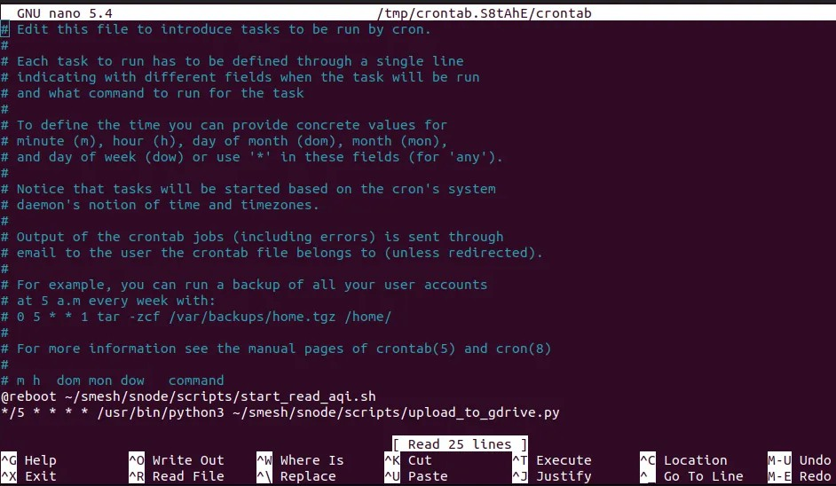

Press to exit the text editor

Ctrl + X

Type



Y

and press

to save your changes

Run the command:

Enter

python3 read_aqi.py /dev/ttyUSB0

The Cron Unix-based job scheduler should now be active, and the

read_aqi.py

upload_to_gdrive.py

and the

~/smesh/snode/data

scripts should be running and uploading the content of folder to your selected Google Drive

# Troubleshooting Tips

 Restart the Cron Unix-based job scheduler:

sudo service cron restart

 Check the Cron Unix-based job scheduler status:

systemctl status cron

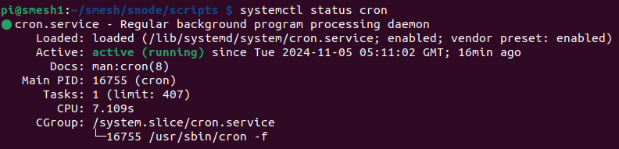

 Test the read_aqi.py script for error:  Navigate to the script directory:

cd ~/smesh/snode/scripts/

 Run the script without providing a serial port number:

python3 read_aqi.py

 If the only error you see is the following, it means all dependencies have been correctly installed:



 Next, run the script by providing the USB0 port (where the Meshtastic should be plugged):

python3 read_aqi.py /dev/ttyUSB0

 If you get an error indicating that the port cannot be found, it measn that the Raspberry Pi is not detecting the Meshtastic. Try to reconnect the

Meshtastic or reboot the Raspberry Pi by entering the command:

reboot

 Note that this will disconnect you from the SSH connection to the Raspberry Pi. Reconnect by entering the command:

ssh [pi@smeshX.local](mailto:pi@smeshX.local)

 Enter the password:

smesh